A PROJECT REPORT

ON

**SMART HOME AUTOMATION USING HC-O5 AND AURDINO** SUBMITTED IN PARTIAL FULFILMENT OF THE REQUIREMENTS OF THE DEGREE OF

B. Tech

BY

B.KAMALSAI 177Y1A05D7

T.HARISH GOUD 187Y1A0477

N.V.SRAVANI DEVI 187Y1A04B6

UNDER THE ESTEEMED GUIDANCE OF





Marri Laxman Reddy Institute of Technology and Management

2019

**ACKNOWLEDGEMENT**

A dissertation work, which integrated skill full and hard work need a great deal of guidance and helping hand. I would like to add a few heartfelt words for the people who have directly or indirectly in preparing in this dissertation work in numerous ways.

My heartfelt thanks to **Marri Laxman Reddy**, chairman of our college for providing me an opportunity to care out this project work form this college.

My sincere thanks to **Dr. K Venkateswara Reddy**, the principal of our college for providing me the required facilities to complete my project.

With profound sense of gratitude and regards, I acknowledge with great pleasure the Guidance and support extended by, **Mr. K Abdul Basith & Mr. K Nagabhushanam**, heads of the Computer Science & Electronics and Communication Engineering departments and internal guide, **Mr. B Prasad** for his timely suggestion, logical thought that have greatly contributed in bringing out the project in a systematic way. He has been inculcating innovative skills and technicalities at all stages at performing this project.

My sincere thanks to all the teaching and non- teaching staff of our department for their constant co-operation extended to me to complete the project successfully. My thanks to all my classmates and friends for their constant help and support during my project work.

My heartfelt gratitude to my parents and my family for their constant encouragement throughout the work carried out to prepare this project report.

SUBMITTED BY

BATCH NO- 02

B.KAMALSAI 177Y1A05D7

T.HARISH GOUD 187Y1A0477

N.V.SRAVANI DEVI 187Y1A04B6

**CONTENTS**

ACKNOWLEDGEMENT ……………………………………………………………………2

ABSTRACT ……………………………………………………………………4

INTRODUCTION …………………………………………………..................5

DESCRIPTION OF THE PROJECT…………………………………….....................6

HARDWARE REQUIREMENTS ………………………………………………………….7

SOFTWARE REQUIREMENTS …………………………………………………...........8

DESCRIPTION ABOUT HARDWARE REQUIRED………………………………….9

HC-05 …………………………………………………………………………………………….10

ARDUINO UNO………………………………………………………………………………12

HC-05 Bluetooth Module Interfacing with Arduino UNO………………13

Sketch for Displaying Data Received Via Bluetooth On Serial Monitor

…………….14

ARDUINO IDE …………………………………………………………………16

MIT APP INVENTOR 2 ………………………………………………………………… 17

PROGRAM CODE ……………………………………………………………………18

CONCLUSION ……………………………………………………………………23

**ABSTRACT**

The main objective of this project is to develop a home automation system using an Arduino board with Bluetooth being remotely controlled by any Android OS smart phone. As technology is advancing so houses are also getting smarter.

Modern houses are gradually shifting from conventional switches to centralized control system, involving remote controlled switches. Presently, conventional wall switches located in different parts of the house makes it difficult for the user to go near them to operate. Even more it becomes more difficult for the elderly or physically handicapped people to do so. Remote controlled home automation system provides a most modern solution with smart phones.

In order to achieve this, a Bluetooth module is interfaced to the Arduino board at the receiver end while on the transmitter end, a GUI application on the cell phone sends ON/OFF commands to the receiver where loads are connected. By touching the specified location on the GUI, the loads can be turned ON/OFF remotely through this technology.

**INTRODUCTION**

Nowadays, we have remote controls for our television sets and other electronic systems, which have made our lives real easy. Have you ever wondered about home automation which would give the facility of controlling tube lights, fans and other electrical appliances at home using a remote control? Off-course, Yes! But, are the available options cost-effective? If the answer is No, we have found a solution to it. We have come up with a new system called Arduino based home automation using Bluetooth. This system is super-cost effective and can give the user, the ability to control any electronic device without even spending for a remote control. This project helps the user to control all the electronic devices using his/her smartphone.

Time is a very valuable thing. Everybody wants to save time as much as they can.New technologies are being introduced to save our time. To save people’s time we are introducing Home Automation system using Bluetooth . With the help of

this system you can control your home appliances from your mobile phone. You can turn on/off your home appliances within the range of Bluetooth.

**DESCRIPTION OF THE PROJECT**

This project is one of the important Arduino Projects. Arduino based home automation using Bluetooth project helps the user to control any electronic device using Device Control app on their Android Smartphone. The android app sends commands to the controller – Arduino, through wireless communication, namely, Bluetooth

The Arduino is connected to the basic shield which has eight led’s. let us consider these eight led’s as different electronic devices.For our conveniencelet us consider, Device 1 – LED, Device 2- Fan, Device 3 – Lights.

When the user speakes ‘led on’ in the app then the Buzzer is switched on

When the user speakes ‘led off’ in the app then the Buzzer is switched off

When the user speakes ‘fan on’ in the app then the fan is switched on

When the user speakes ‘fan off’ in the app then the fan is switched off

When the user speakes ‘light on’ in the app then the light is switched on

When the user speakes ‘light off’ in the app then the light is switched

Off

When the user speakes ‘all on’ In the app then the electronic device is switched on

When the user speakes ‘all off’ in the app then the electronic device is switched Off

**HARDWARE REQUIREMENTS**

1. HC-05(BLUETOOTH)
2. ARDUINO UNO
3. LED’S
4. WIRES

**SOFTWARE REQUIREMENTS**

1.ARDUINO IDE

2.MIT APP INVENTOR 2

**DESCRIPTION ABOUT HARDWARE REQUIRED**

**1.HC-05 BLUETOOTH MODULE**

HC-05 module is an easy to use Bluetooth SPP (Serial Port Protocol) module, designed for transparent wireless serial connection setup.

Serial port Bluetooth module is fully qualified Bluetooth V2.0+EDR (Enhanced Data Rate) 3Mbps Modulation with complete 2.4GHz radio transceiver and baseband. It uses CSR Blue core 04-External single chip Bluetooth system with CMOS technology and with AFH (Adaptive Frequency Hopping Feature). It has the footprint as small as 12.7mmx27mm. Hope it will simplify your overall design/development cycle.

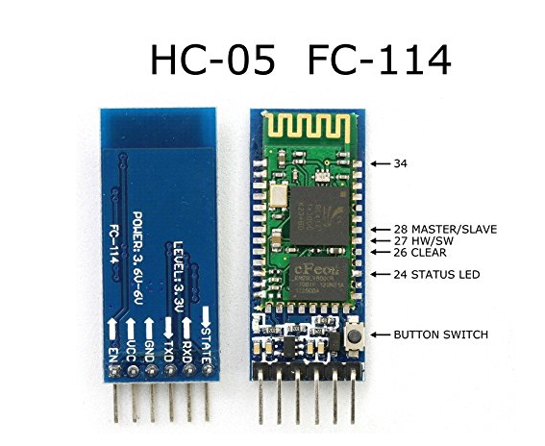

**ARDUINO UNO**

The Arduino Uno is a microcontroller board based on the ATmega328P. It has 14 digital input/output pins (of which 6 can be used as PWM outputs), 6 analog inputs, a 16 MHz crystal oscillator, a USB connection, a power jack, an ICSP header, and a reset button. It contains everything needed to support the microcontroller; simply connect it to a computer with a USB cable or power it with a AC-to-DC adapter or battery to get started. The Uno differs from all preceding boards in that it does not use the FTDI USB-to serial driver chip. Instead, it features the Atmega8U2 programmed as a USB-to serial converter.

Some Technical Specification of Arduino Uno are:

1. Microcontroller ATmega328P

2. Operating Voltage 5V

3. Input Voltage (recommended) 7-12V

4. Input Voltage (limits) 6-20V

5. Digital I/O Pins 14

6. Analog Input Pins 6

7. DC Current per I/O Pin 40 mA

8. DC Current for 3.3V Pin 50 mA

9. Flash Memory 32 KB of which 0.5 KB used by bootloader

10.SRAM 2 KB

11.EEPROM 1 KB

12.Clock Speed 16 MHz

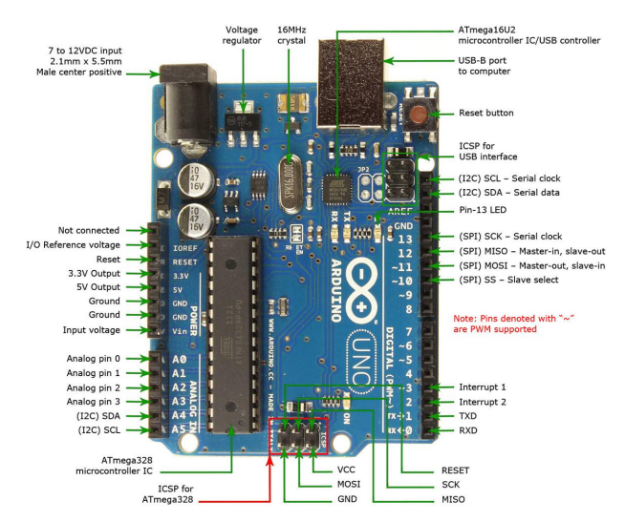 **HC-05 Bluetooth Module Interfacing with Arduino UNO**

HC-05 is a Bluetooth device used for wireless communication with Bluetooth enabled devices (like smartphone). It communicates with microcontrollers using serial communication (USART). Default settings of HC-05 Bluetooth module can be changed using certain AT commands. As HC-05 Bluetooth module has 3.3 V level for RX/TX and microcontroller can detect 3.3 V level, so, there is no need to shift TX voltage level of HC-05 module. But we need to shift the transmit voltage level from microcontroller to RX of HC05 module.

CONNECTIONS:

HC-05 ARDUINO UNO

1.RX TX

2.TX RX

3.GND GND 4.VCC 3V3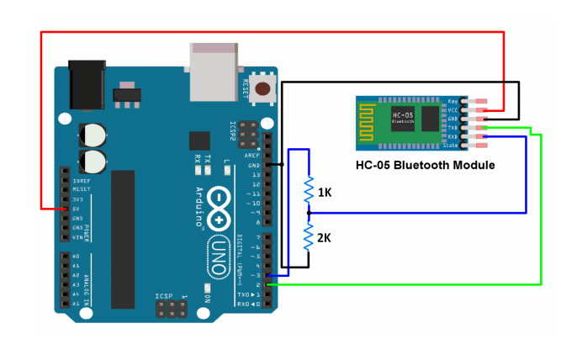

**Sketch for Displaying Data Received Via Bluetooth On Serial Monitor**

#include<SoftwareSerial.h>

/* Create object named bt of the class SoftwareSerial */

SoftwareSerial bt(2,4); /* (Rx,Tx) */

void setup()

{

bt.begin(9600); /* Define baud rate for software serial communication */

Serial.begin(9600); /* Define baud rate for serial communication */

}

void loop()

{

if (bt.available()) /* If data is available on serial port */

{

Serial.write(bt.read()); /* Print character received on to the serial monitor */

}

}

**DESCRIPTION ABOUT SOFTWARE REQUIRED**

**ARDUINO IDE**

The **Arduino integrated development environment (IDE)** is a cross-platform application (for Windows, macOS, Linux) that is written in the programming language Java. It is used to write and upload programs to Arduino compatible boards, but also, with the help of 3rd party cores, other vendor development boards.

The source code for the IDE is released under the GNU General Public License, version 2. The Arduino IDE supports the languages C and C++ using special rules of code structuring. The Arduino IDE supplies a software library from the Wiringproject, which provides many common input and output procedures. User-written code only requires two basic functions, for starting the sketch and the main program loop, that are compiled and linked with a program stub *main()* into an executable cyclic executive program with the GNU toolchain, also included with the IDE distribution. The Arduino IDE in employs the program *avrdude* to convert the executable code theArduino board by a loader program in the board's firmware

into a text file in hexadecimal encoding that is loaded into the Arduino board by a loader program in the board's firmware

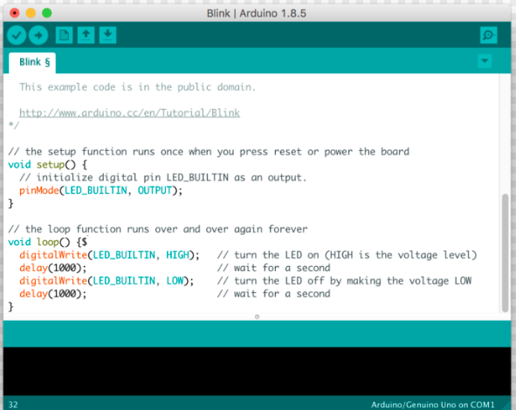

**MIT APP INVENTOR 2**

**App Inventor for Android** is an open-source web application originally provided by Google, and now maintained by the Massachusetts Institute of Technology (MIT), which allows newcomers to computer programming to create software applications for the Android operating system (OS).

It uses a graphical interface very similar to Scratch and the StarLogo TNG user interface, which allows users to drag-and-drop visual objects to create an application that can run on Android devices. In creating App Inventor, Google drew upon significant prior research in educational computing, as well as work done within Google on online development environments.

App Inventor and the projects on which it is based are informed by constructionist learning theories, which emphasizes that programming can be a vehicle for engaging powerful ideas through active learning. As such, it is part of an ongoing movement in computers and education that began with the work of Seymour Papert and the MIT Logo Group in the 1960s and has also manifested itself with Mitchel Resnick's work on Lego Mindstorms and StarLogo.

App Inventor also supports the use of cloud data via an experimental FirebaseDB component

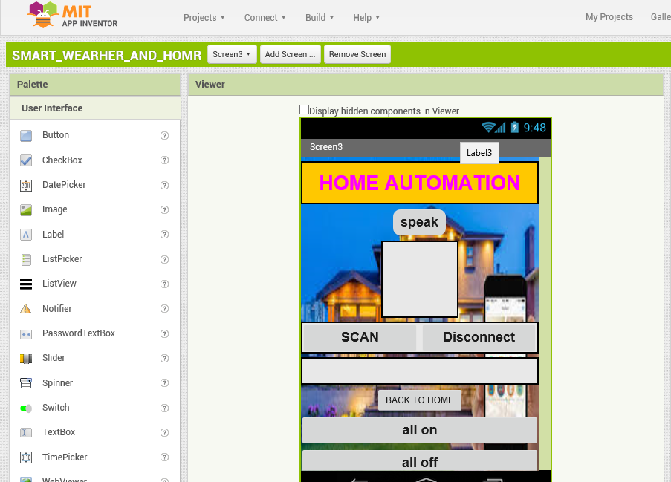

**PROGRAM CODE FOR SMART HOME AUTOMATION USING VOICE CONTROL AND BLUETOOTH**

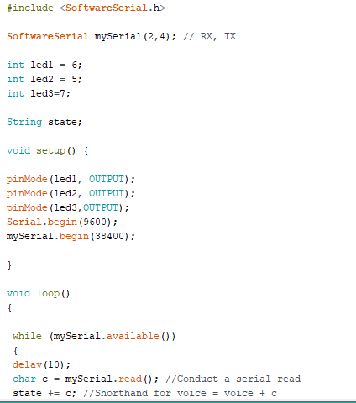

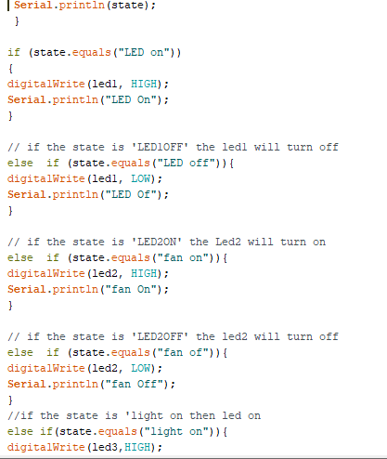

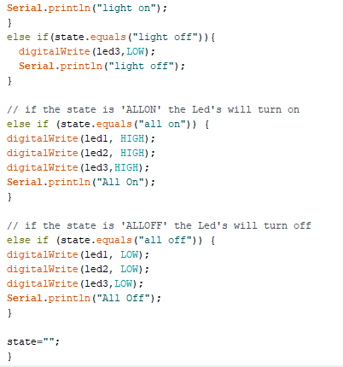

**WHEN COMMAND LIGHT ON**

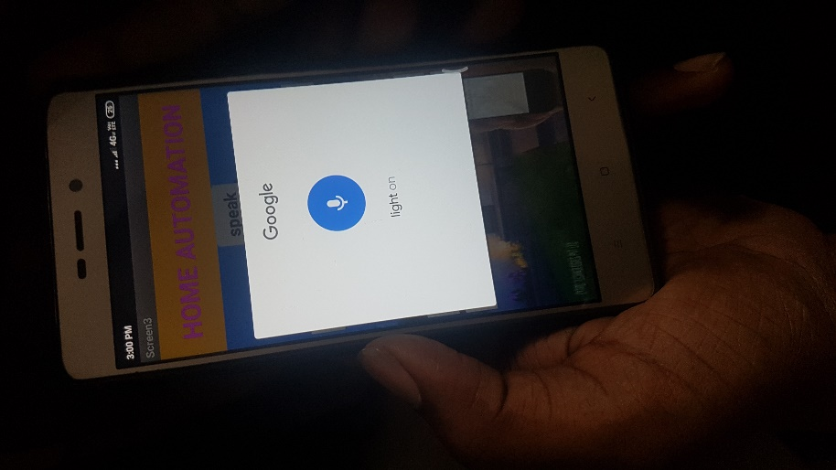

**RESULT**

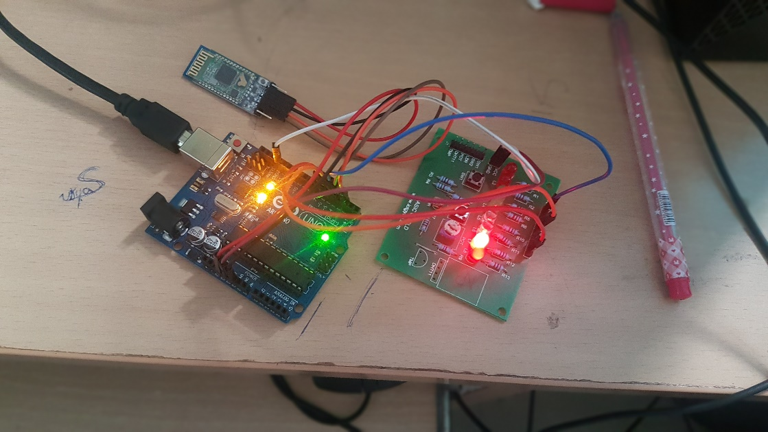

**WHEN COMMAND ALL ON**

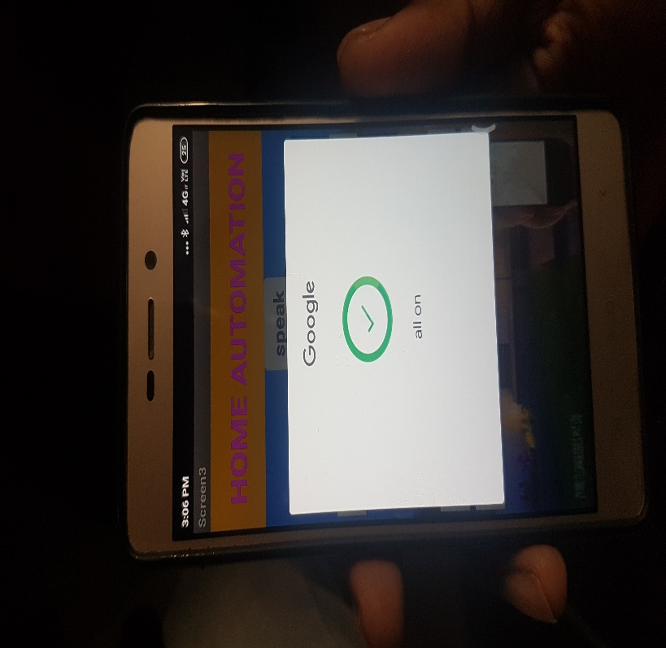

**RESULT**

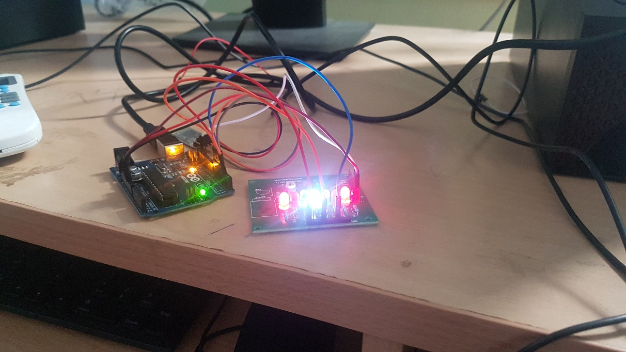

**CONCLUSION**

The home automation system has been experimentally proven to work satisfactorily by connecting sample appliances to it and the appliances were successfully controlled from a wireless mobile device

The Bluetooth client was successfully tested on a multitude of different mobile phones from different manufacturers, thus proving its portability and wide compatibility. Thus a low-cost home automation system was successfully designed, implemented and tested.